



**Thenmozhi R**

**BY**

PHARMA DATA ANALYSIS USING SQL

**INTERNSHIP PROJECT**

1. Retrieve all columns for all records in the dataset.

LOAD DATA

INTO TABLE pharma_tb

FIELDS TERMINATED BY ','

ENCLOSED BY '"'

LINES TERMINATED BY '\n'

IGNORE 1 ROWS;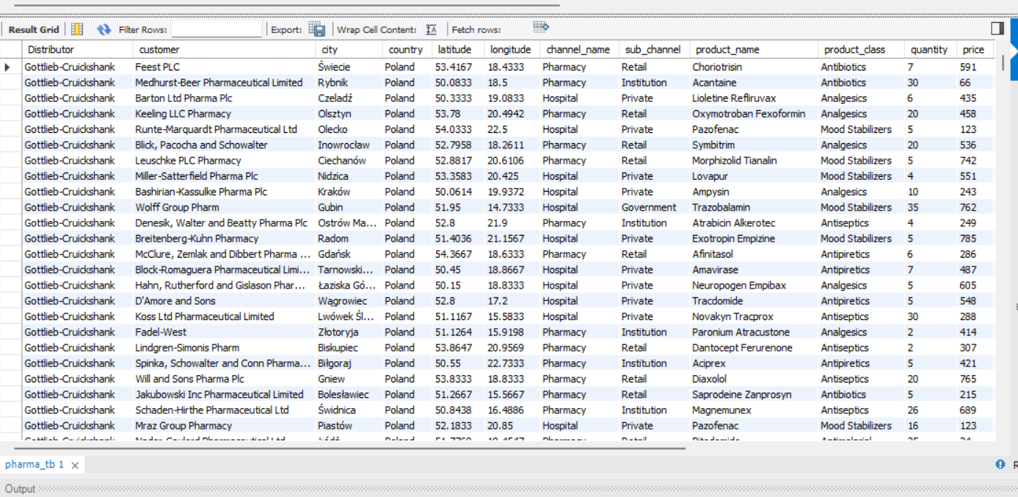

2. How many unique countries are represented in the dataset?

SELECT DISTINCT country from pharma_tb;

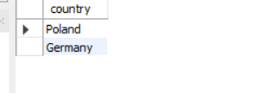

3. Select the names of all the customers on the 'Retail' channel.

SELECT customer

FROM pharma_tb

WHERE sub_channel = 'Retail';

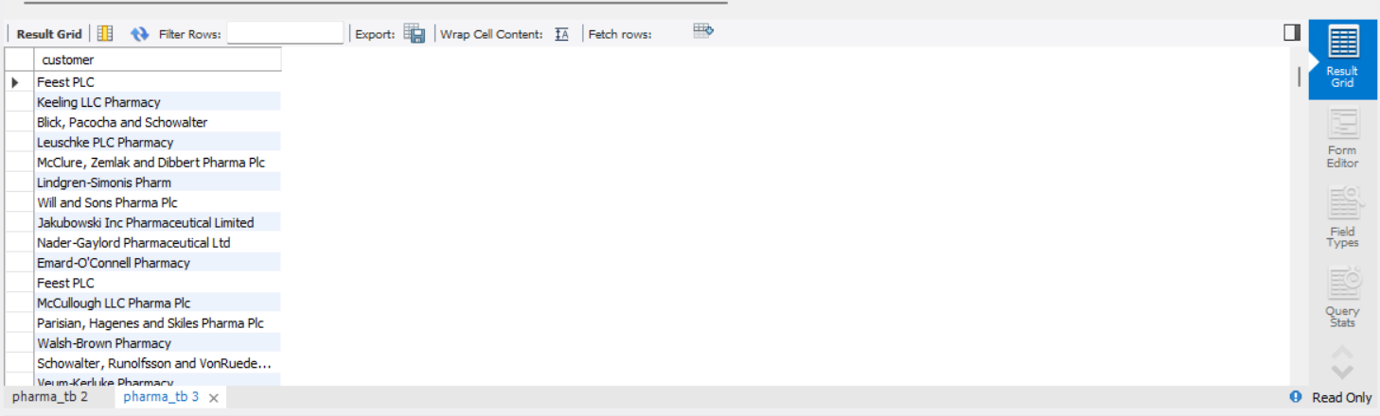

4. Find the total quantity sold for the ' Antibiotics' product class.

SELECT product_class ,sum(quantity) total_quantity

FROM pharma_tb

group by product_class

having product_class='Antibiotics';

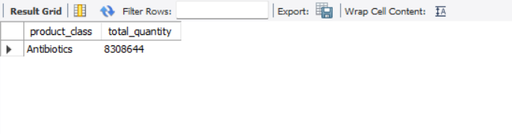

5. List all the distinct months present in the dataset

select distinct month_name from pharma_tb;

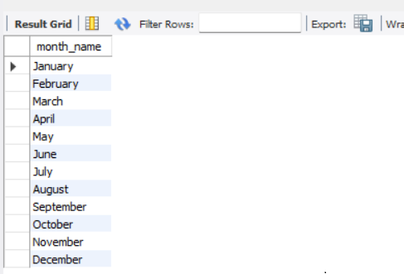

6. Calculate the total sales for each year

select year_,sum(sales) as sales

from pharma_tb group by year_;

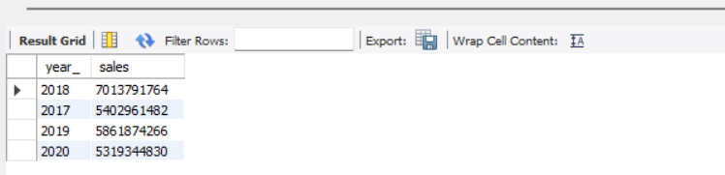

7. Find the customer with the highest sales value.

SELECT customer, SUM(sales) AS highest_sales

FROM pharma_tb

GROUP BY customer

ORDER BY highest_sales DESC

LIMIT 1;

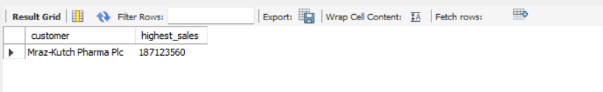

8. Get the names of all employees who are Sales Reps and are managed by 'James Goodwill'.

select name_of_the_sales_rep,manager from pharma_tb where manager='James Goodwill';

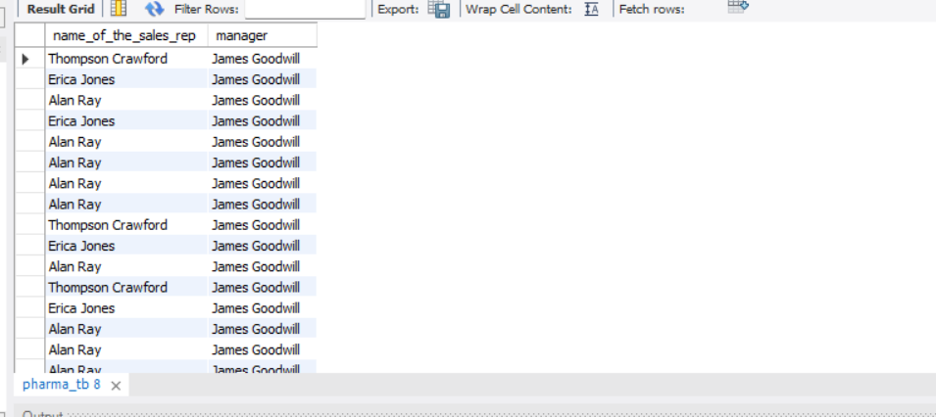

9. Retrieve the top 5 cities with the highest sales

SELECT city, SUM(sales) AS highest_sales

FROM pharma_tb

GROUP BY city

ORDER BY highest_sales DESC

LIMIT 5;

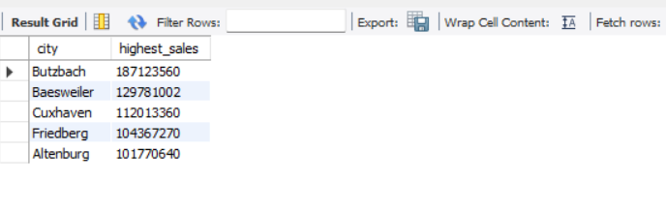

10. Calculate the average price of products in each sub-channel.

select sub_channel,avg(price) as average_price from pharma_tb

group by sub_channel;

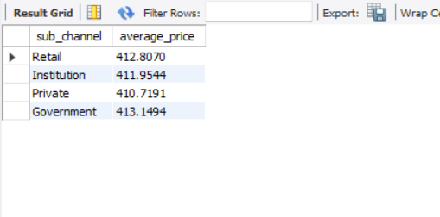

11. Join the 'Employees' table with the 'Sales' table to get the name of the Sales Rep and the corresponding sales records

select name_of_the_sales_rep,sum(sales) from pharma_tb group by name_of_the_sales_rep;

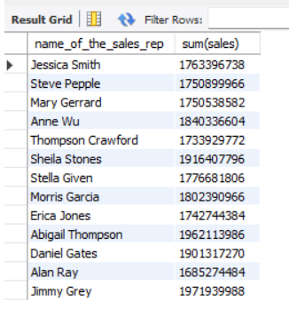

12. Retrieve all sales made by employees from ' Rendsburg ' in the year 2018.

select*from pharma_tb where city='Rendsburg' and year_=2018;

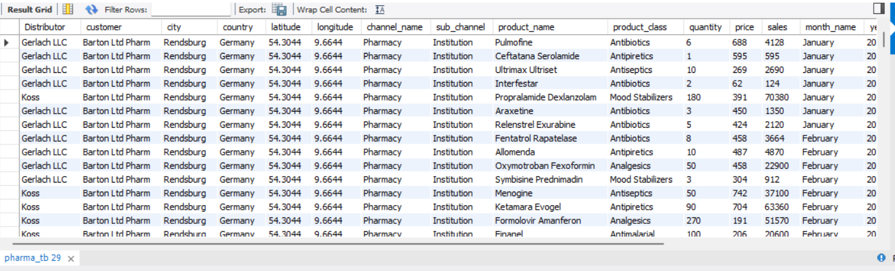

13. Calculate the total sales for each product class, for each month, and order the results by year, month, and product class

SELECT product_class, month_name, year_, SUM(sales) as total_sales

FROM pharma_tb

GROUP BY product_class, month_name, year_

LIMIT 50000;

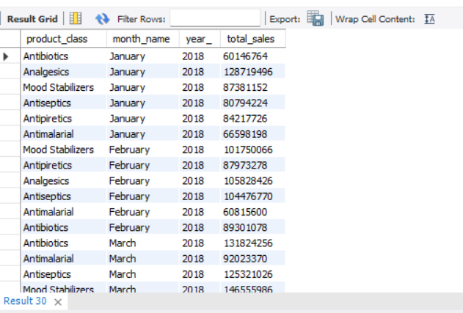

14. Find the top 3 sales reps with the highest sales in 2019

SELECT name_of_the_sales_rep, SUM(sales) AS total_sales

FROM pharma_tb

WHERE YEAR_ = 2019

GROUP BY name_of_the_sales_rep

ORDER BY total_sales DESC

LIMIT 3;

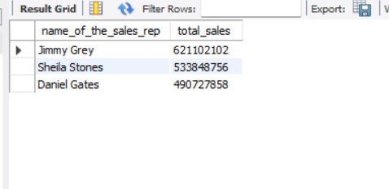

15. Calculate the monthly total sales for each sub-channel, and then calculate the average monthly sales for each sub-channel over the years.

SELECT

YEAR_ AS sales_year,

month_name AS sales_month,

sub_channel,

SUM(sales) AS monthly_sales

FROM pharma_tb

GROUP BY sales_year, sales_month, sub_channel

ORDER BY sub_channel, sales_year, sales_month;

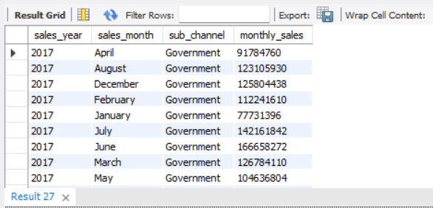

16. Create a summary report that includes the total sales, average price, and total quantity sold for each product class.

SELECT

product_class,

SUM(sales) AS total_sales,

AVG(price) AS average_price,

SUM(quantity) AS total_quantity_sold

FROM pharma_tb

GROUP BY product_class

ORDER BY product_class;

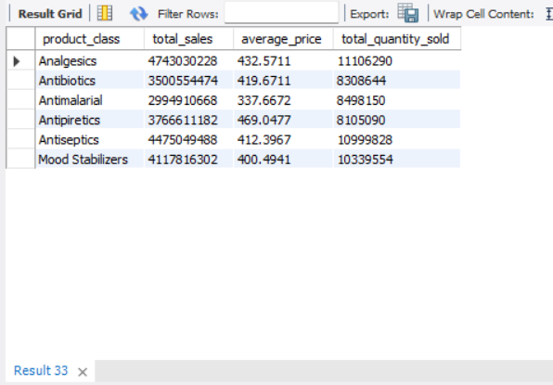

17. Find the top 5 customers with the highest sales for each year.SELECT year_, customer, total_sales

FROM (

SELECT year_, customer, SUM(sales) AS total_sales,

ROW_NUMBER() OVER (PARTITION BY year_ ORDER BY SUM(sales) DESC) AS sales_rank

FROM pharma_tb

GROUP BY year_, customer

) ranked_sales

WHERE sales_rank <= 5;

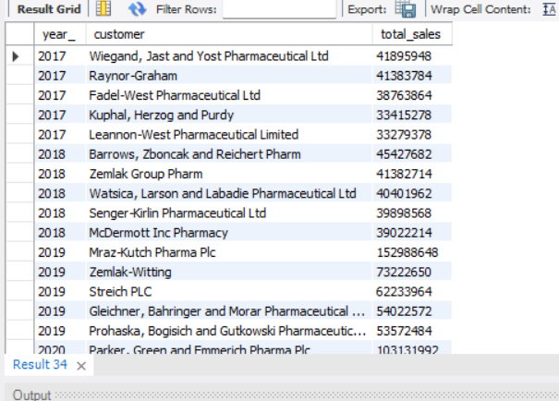

18. Calculate the year-over-year growth in sales for each country.

select country,round(sum(sales))as total_sales,year_ from pharma_tb group by year_,country

order by year_;

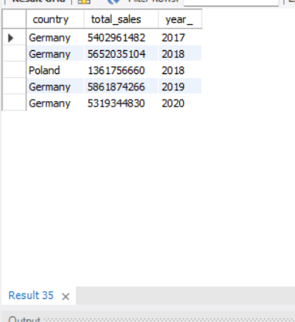

19. List the months with the lowest sales for each year

SELECT year_, month_name, MIN(total_sales) AS lowest_sales

FROM (

SELECT YEAR_ AS year_, MONTH_NAME AS month_name, SUM(sales) AS total_sales

FROM pharma_tb

GROUP BY YEAR_, MONTH_NAME

) AS sales

GROUP BY year_, month_name

LIMIT 0, 50000;

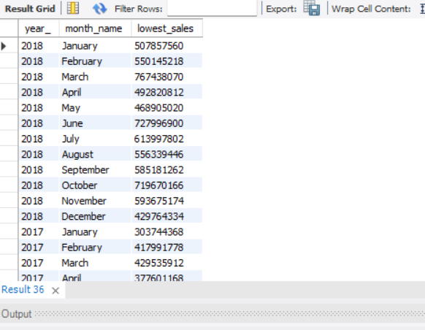

20. Calculate the total sales for each sub-channel in each country, and then find the country with the highest total sales for each sub-channel.

WITH tot_sales AS (

SELECT

RANK() OVER(PARTITION BY sub_channel ORDER BY SUM(sales)) AS rnk,

SUM(sales) AS total_sales,

country,

sub_channel

FROM pharma_tb

GROUP BY country, sub_channel

)

SELECT

tot_sales.country,

tot_sales.sub_channel,

tot_sales.total_sales

FROM tot_sales

WHERE tot_sales.rnk = 1;

